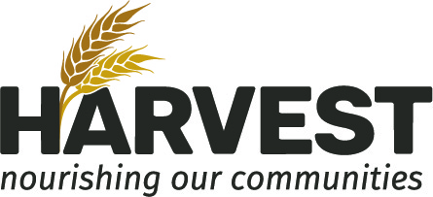

KIT COUNT SHEET

All Food banks must report the amount of kit items and milk left after each food bank via:
- Email: agency.food.relations@harvestmanitoba.ca
- Phone: 204.982.3663 ext. 433
- Fax: 204.775.4180 (Attention: Greg Schroeder, Agency Food Relations Associate)

Food Bank: _________________________________________ Date of Food Bank: _________________

Please submit at least 48 hours prior to your next run date:

Day of the week: □ Monday □ Tuesday □ Wednesday
□ Thursday □ Friday □ Saturday

Items left over (by units):
Non-perishable Boxes: __________
Perishable Boxes: Please do not keep, hand out as extras or to walk-ins
Green Taped Bags: Please do not keep, hand out as extras or to walk-ins
Freezer Items/Bags: Please do not keep, hand out as extras or to walk-ins
Baby Kits: __________
Milk kept on site: __________
Milk returned to Harvest: __________

Number of registered clients who received non-perishable box today: _____________

Walk-ins are not to receive non-perishable boxes. They may receive any of the perishable food left over after the registered clients are finished. Please encourage them to make a food bank appointment with Harvest Manitoba by calling 204.982.3660 or email appointments@harvestmanitoba.ca.

Number of walk-ins: _____________

If you have any questions about this form, please call the Agencies Office at 204.982.3663 Ext. 433 and speak with an Agency Team Member.

